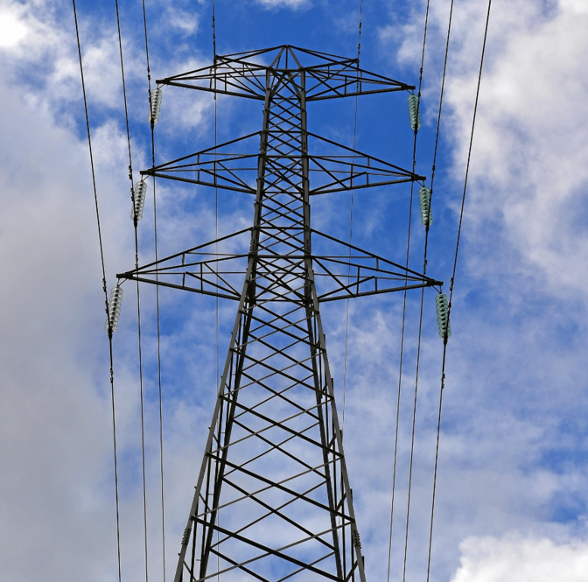S

**Georgios Statiris 12403616 19/10/2018  
Phi Dinh 12026530**

Power Circuit Theory - 2018 – 48572  
Group Assignment

Investigation on Electrical System

Acknowledge of contribution

|  |  |
| --- | --- |
| Georgios Statiris 12403616 | Phi Dinh 12026530 |
| Report making contribution | |
| Wind energy research | Introduction |
| Wind farm design | Energy Demand analysis |
| Wind turbines design | Location analysis of substation and power stations |
| Energy output | Cost analysis |
| Part2 | Transmission network |

For the following report, the initial plan was each member to do the following sections:

|  |  |  |  |
| --- | --- | --- | --- |
| Section | Completion | Georgios Statiris (12403616) | Phi Dinh (12026530) |
| Pages done | | All pages but 5-8 | Pages 5,6,7,8 |
| Report making | Done | 100% | No contribution |
| Introduction | Done | 100% | No contribution |
| “Wind energy” | Done | 100% | Not responsible |
| “The structure” | Done | 100% | No contribution |
| “Energy Output“ | Done | 100% | No contribution |
| “Transmission Network“ | Done | 100% | No contribution |
| Part2 | Done | 100% | Not responsible |
| Cost | - | Not responsible | - |
| Location analysis | - | Not responsible | - |
| Demand Analysis | - | Not responsible | - |

There has been a bad communication established between the students. It appears that some of the members did not manage to do their part of the assignment as initially had been discussed. As a result, the contribution of the 2 students, has clearly not been equal. Below is a detailed summary of how the workload ended up being.

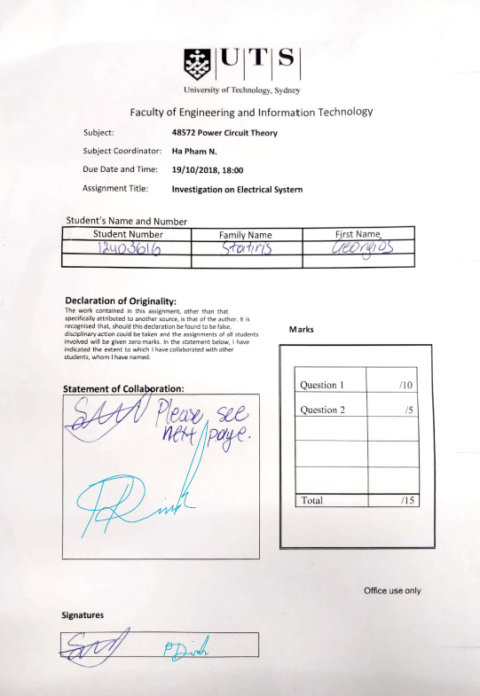

Table of Contents

Introduction 5

Wind Energy 9

How wind turbines work 9

Different types of wind turbines: 10

Wind Speed and Energy: 12

How height affects the wind speed and the power output 13

The structure 15

Type of offshore towers: Monopile 15

Type of onshore type: Octagonal gravity base foundation 16

Driven Pipe Pile 16

Wind turbines model selection 17

Energy Output 18

Transmission Network 21

Substations 22

Main components of a substation 23

Transformers 26

Transmission lines 27

Conductors 27

Capacitance and Inductance 29

Transmission towers 30

Distribution towers 30

PART 2 32

Single line-to-ground fault: 32

Line-to-Line faults: 33

Double Line-to-Ground faults: 34

Protection Suggestion 35

References 37

Georgios Statiris References 37

Phi Dinh References 38

Figure 1 Wind speed intensity NSW 5

Figure 2 Offshore wind farm diagram 6

Figure 3 Onshore windfarm diagram 6

Figure 4 Main components of a wind turbine 7

Figure 5 Different types of wind turbines 8

Figure 6 Wind turbines height evolution 10

Figure 7 Vertical profile of wind speed 11

Figure 8 Various types of support structures and their applicable water depth (Malhotra, 2007b, c) 12

Figure 9 Octagonal Base Foundation 13

Figure 10 HHP30 hydraulic hammer hammering φ1700mm, 82 meters long steel pipe pile 13

Figure 11 Capacity factor of power plants Australia 15

Figure 12 Actual example of Capacity factor NSW 15

Figure 13 Transmission Network 18

Figure 14 Distribution Substation diagram 19

Figure 15 Delta-Wye circuit diagram 23

Figure 16 Double circuit arrangement (PCT Spring 2018 Lecture slides) 24

Figure 17 Double circuit Conductor arrangement 24

Figure 18 PCT Spring 2018 Lecture 3 slides 24

Figure 19 Conductor Specifications 25

Figure 20 Transmission lines Spacers 25

Figure 21 Main components of transmission towers 27

Figure 22 415V insulator 28

Figure 23 415V power line with 4 conductors 28

Figure 24 11kV insulator 28

Figure 25 11kV power like mouned on top of 415V 28

Figure 26 Glass disc insulator on 33kV powerline 28

Figure 27 33kV powerline with 28

Figure 28 stack of discs 28

*Figure 30 66kV triangular powerline* 28

Figure 29 Disc insulators 28

Figure 31 Single line-to-ground fault (Saadat 1999) 29

Figure 32 Sequence network for Single line-to-ground fault (Grainger, 1994) 29

Figure 33 Line-to-Line fault (Grainger, 1994) 30

Figure 34 Line-to-line fault (Saadat, 1999) 30

Figure 35 Sequence network connection for line-to-line (Saadat, 1999) 30

Figure 36 Double Line-to-Ground fault (Saadat, 1999) 31

Figure 37 Double line-to-ground fault (Grainger, 1994) 31

Figure 38 Sequence network for Double line-to-ground fault 31

Figure 39 SF6 circuit breaker 32

Figure 41 Breaking procedure 33

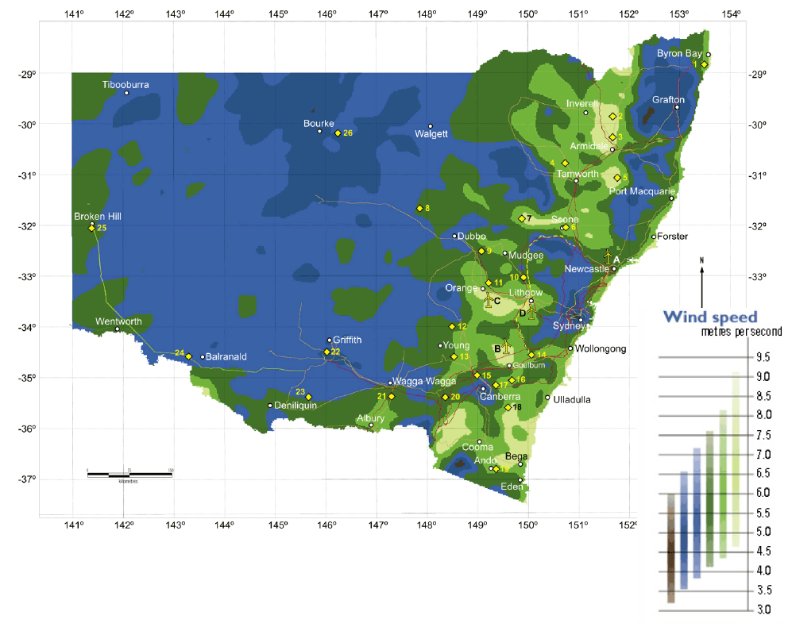Introduction

Figure 1 Wind speed intensity NSW

One of the largest generators in NSW is the Eraring Generator. Eraring produces a maximum capacity of 2,880 MW of power. With this power it supplies a quarter of NSW total power. However it generates its power by using burning coal. As a consequence it produces a biproduct of 0.92 tonnes of CO2 per KWH. Seeing as how its estimated closure is around 2032, we propose to 2 wind farm generators to replace the coal-fired generator and use that generator as a target for output generation. With the replacement with a renewable energy generator it will bring Australia one step closer to eradicating Green House gas emissions.

The proposed wind farms will be placed in 2 different locations; the first to the west of Sydney, 30Km towards the west, the other is offshore 20Km east of Sydney.

|  |  |
| --- | --- |
| Estimated Population of Cities in New South Wales by June 2018 | |
| Cities: | Population (people): |
| Sydney | 5,640,000 |
| Newcastle | 446,227 |
| Canberra | 406,057 |
| Wollongong | 215,079 |
| Orange | 38,029 |
| New South Wales | 7,880,000 |

The current demand of NSW is 8500MW as the peak across the span of a day which is roughly 354MWh. Knowing Sydney takes up 70% of the population, the ratio is shown similar for energy demand and consumption.

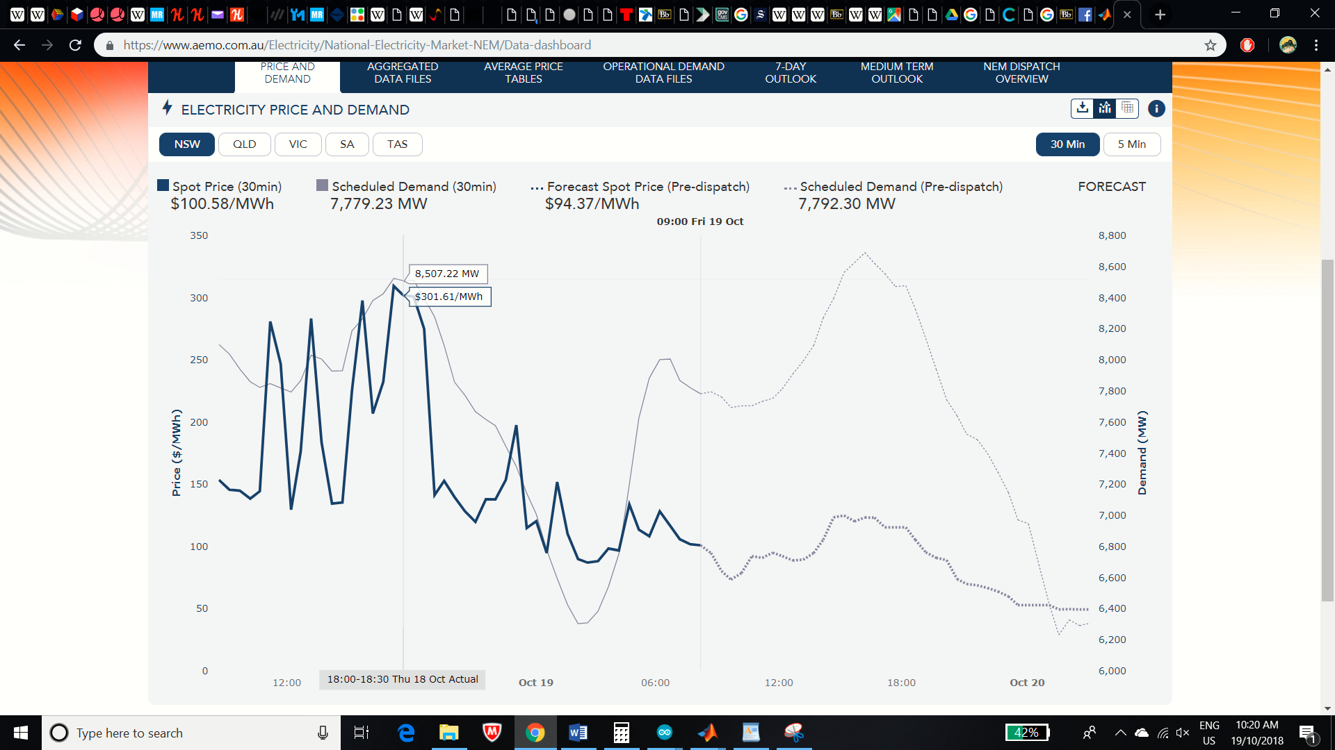

The Inland Generator will power Orange, Canberra, New Castle and Wollongong, while the offshore wind farm will solely power the Sydney bus.

Offshore Cable:

The type of cable proposed will be the submarine cables running underwater from the offshore wind farm 20Km into shore to a substation to step down the voltage. The cable has a cross sectional area of a circle. The cable itself is different to a typical overhead transmission line as the cable has all three phase lines within one cable. Furthermore, the cables are below water and does not use air to regulate the temperature within it. Therefore, it must include an optic cable to measure the temperature. To regulate the temperature, oil is used for its high boiling point. The cable also has a strong insulation to prevent magnetic and electrical leakage as well as the oil leakage. The material of the insulation is cross-linked polyethylene which allows conduction of up to 420 kV to pass through.

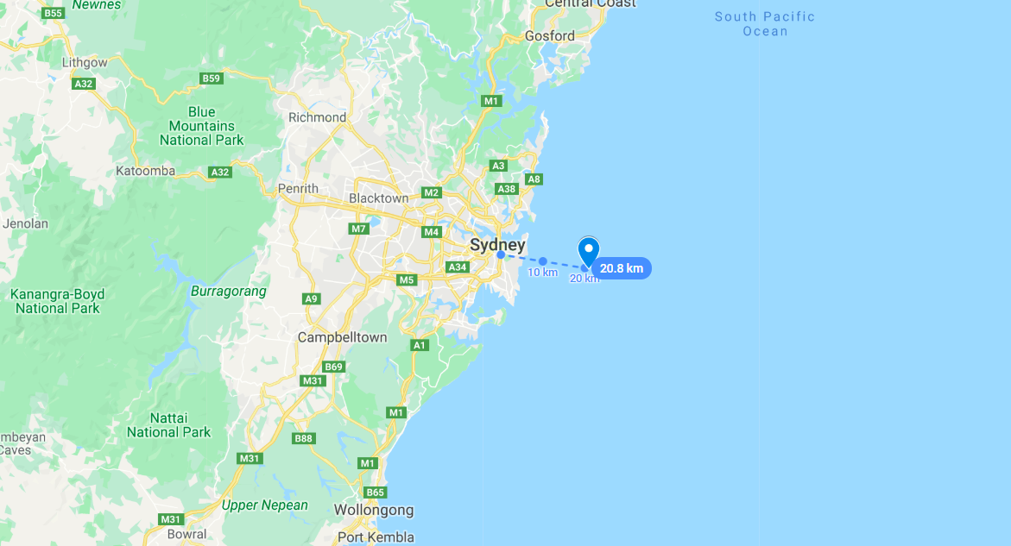

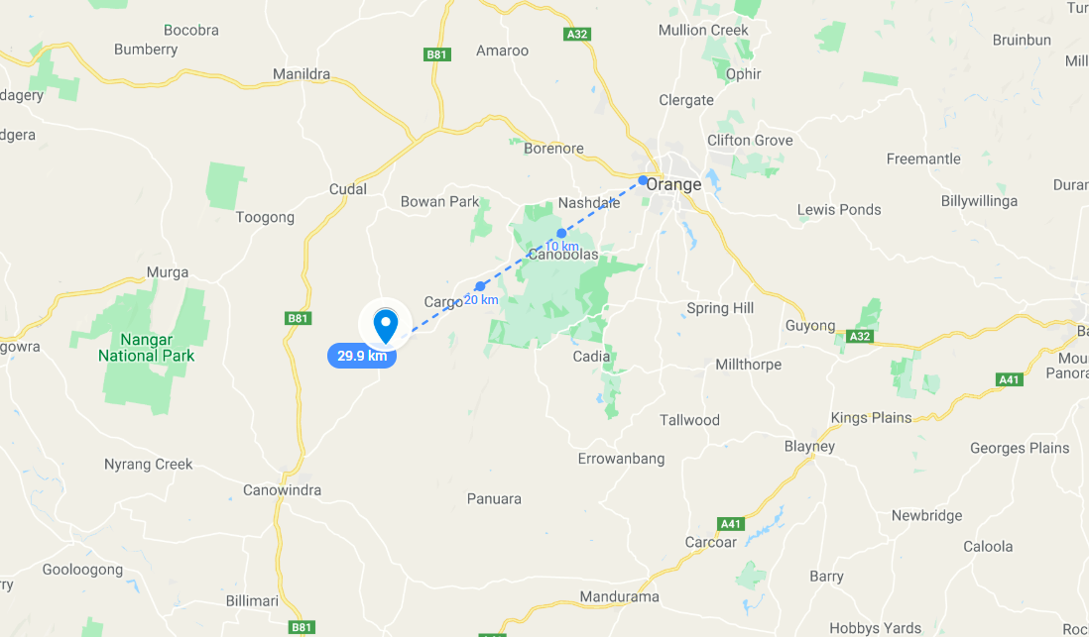

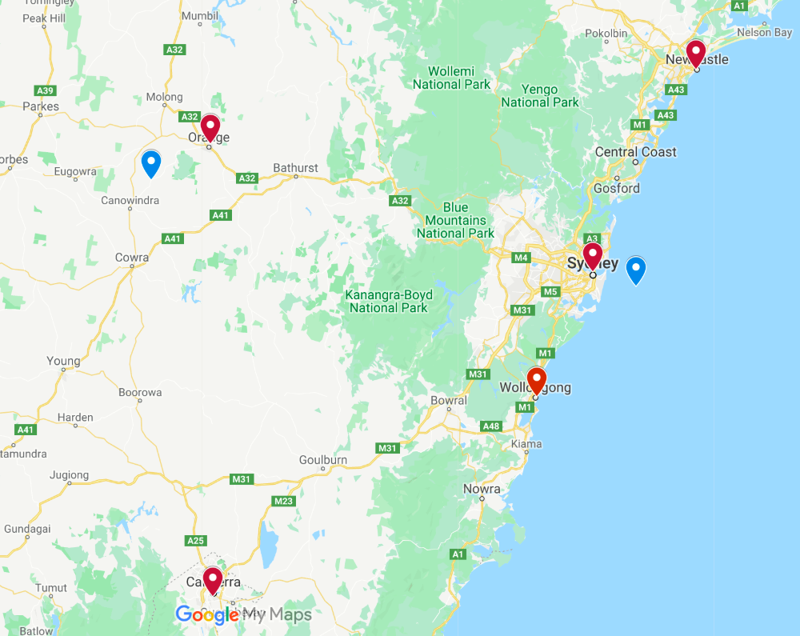

Wind energy is one of the most promising source of renewable energy in the world. As it will be discussed, it might be more expensive to establish the windfarm but once it is established, it is very cheap to run and produce energy.   
Australia is one of the most promising countries in the world for this source, because the amount of wind is enormous in many areas.   
There have already been established 29 wind farms all over Australia with the biggest capacity ones being:

* Macarthur Wind farm Victoria, Capacity: 420MW
* Snowtown Group South Australia Capacity: 369MW
* Hallett Group South Australia Capacity: 351MW
* Hornsdale Wind Farm South Australia Capacity: 316MW

*It is worth mentioning that the Macarthur Wind farm is the largest wind farm in the southern hemisphere.

And 7 more being under construction, including:

* Coopers Gap Queensland Capacity: 453MW
* Sapphire Wind Farm New South Wales Capacity: 270MW

While many more projects have already been planned and approved, with the biggest one being the Liverpool Range windfarm project, which will consist of 267 wind turbines with a combined output of more than 1000MW.

Wind Energy

How wind turbines work

Wind flows through a turbine which then forces the rotor blades of the tower to rotate. This translates to the transformation of the kinetic energy of the wind into mechanical energy of the rotating turbine.  
While the turbine rotates, it drives a shaft which drives a power generator. Through the principal of electromagnetic induction, current is generated at a lower voltage and then transformed to a higher voltage via a step-up transformer usually located on the bottom of the turbine, in order to deliv

er the electricity through long transmission lines to a stepdown substation and then be distributed to the consumers.   
The typical modern wind turbine has an electric power output between 600 and 3000 kW (while new models are already being built that can reach even up to 9000kW)

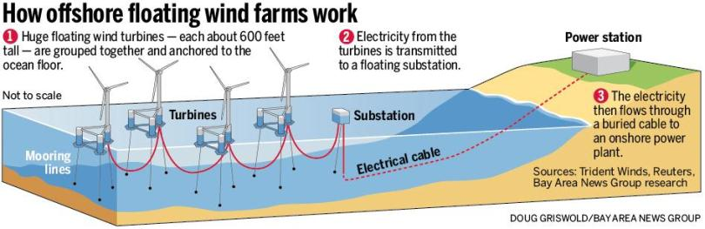How **offshore** wind turbines work  
*How* ***onshore*** *wind turbines work*

Figure Offshore wind farm diagram

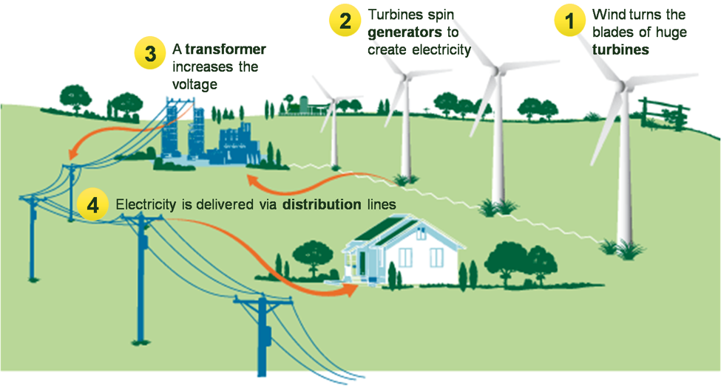

*:*

Figure Onshore windfarm diagram

Different types of wind turbines:

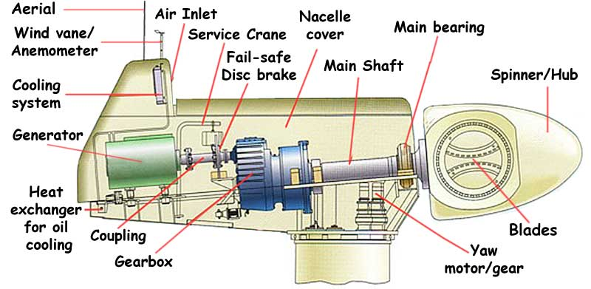

Figure 4 Main components of a wind turbine

Main components of wind turbine:

* Tower and blades
* Main shaft with mechanical gearbox
* Electrical Generator
* Cooling unit
* Sensors, control, anemometer and wind vane
* Yaw mechanism

Wind turbines usually they consist of 2 or 3 blades. They can be upwind (facing into the wind) or downwind (facing away from wind).   
They can be of different type or shape, tall or short. In our wind farms we have chosen to use the typical 3 blade Horizontal Axis Wind turbines.

In terms of shape, they are mainly divided into two categories(Dylan LU 2018):

* HAWT (Horizontal-Axis Wind Turbines): they are used in both small or large systems or wind farms
  + Advantages: can be very tall, and reach high heights were the wind speed is much higher; they are very efficient
  + Disadvantages: Complex system with high installation cost because the generator and the gearbox need to be placed on top of the tower
* VAWT (Vertical-Axis Wind Turbines): They are usually used in small system (for example on top of medium size building, like UTS Building 11 has)
  + Advantages: they are much cheaper to be built because the generator and the gearbox can be installed on the ground of the tower; they are easier to transport; they do not need yaw mechanism
  + Disadvantages: less efficient/less energy generation because wind speed is much slower on the ground level; require more maintenance

**In our design** we are going to use only HAWT wind turbines with a 3-blade configuration, for both the onshore and offshore wind farm. That is because we need them to be tall and strong because both of our wind farms will be in open space with strong wind currents and space restriction will not be an issue.

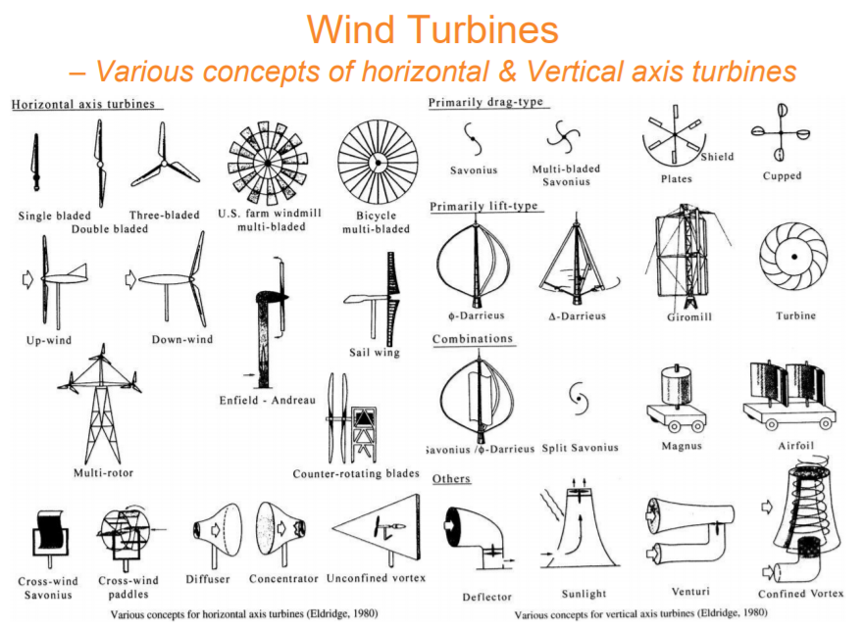Most of the wind turbines types are shown below in the diagram:

Figure Different types of wind turbines

Wind Speed and Energy:

Table 1 Wind characteristics

|  |  |  |
| --- | --- | --- |
| Symbol | Discerption | Unit |
| m | Mass of wind | Kg |
| v | Speed of wind | m/s |
| P | Mechanical power of air | Watts |
| ρ | Air density | Kg/m3 |
| A | Area covered by the rotation of the blades | m2 |
| V | Upstream wind velocity | m/s |
| Vo | Downstream wind velocity | m/s |

$$Wind blade diameter:A=π*r^{2}=\frac{π}{4}*D^{2}$$

$$ρ=\frac{P}{RT}=1.225 K_{T}K_{A}$$

$${Where K}_{T} and K_{A }are correction factors for ρ for referencing to {15}^{o}C and \\ sea level respectively$$

$Kinetic Energy:K.E=\frac{1}{2}m*v^{2}$

$$Power=\frac{1}{2}\left(mass flow per second\right)*v^{2}$$

$$Mass flow rate of the air=ρ*A*\frac{V+V_{o}}{2}$$

The mechanical power in the turbine:

$$P=\frac{1}{2}\left[ρA \frac{V+V_{o}}{2}\right]\left(V^{2}-V_{o}^{2}\right) \\ ⇒P=\frac{1}{2}ρAV^{3}\left(\frac{\left(1+\begin{aligned}V_{o} \\ V\end{aligned}\right)\left(1+\frac{V_{o}^{2}}{V^{2}}\right)}{2}\right) \\ ⇒P=\frac{1}{2}ρAV^{3}C_{p}, where C_{p}=\frac{\left(1+\begin{aligned}V_{o} \\ V\end{aligned}\right)\left(1+\frac{V_{o}^{2}}{V^{2}}\right)}{2}$$

$$\left(\frac{P}{P_{o}}\right)={\left(\frac{U}{U_{o}}\right)}^{3}={\left(\frac{H}{H_{o}}\right)}^{3α}$$

Power, Wind speed and tower height

How height affects the wind speed and the power output

Everywhere on earth, the higher you go from the surface to the atmosphere/sky, the stronger the wind will be.   
The scientific reason behind this is because the higher you are in the atmosphere the thinner the air becomes (less dense). That means that wind will need less force to be pushed on the air when it is in higher altitudes.   
On the other hand, the closer you get to the ground level (earth) wind is slowed down due to the friction on the wind created by obstacles such as buildings, mountains, trees etc.  
Of course, offshore wind turbines hold a strong advantages over onshore, because out in the ocean there are no obstacles and the tower can be built very high, drawing very high wind speeds. 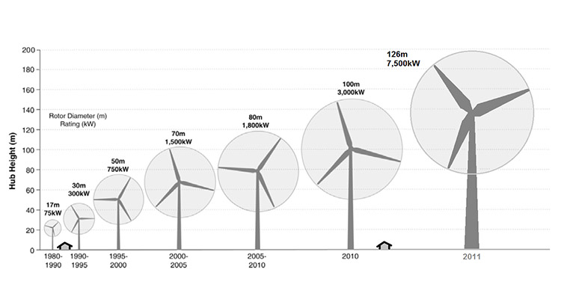

Figure 6 Wind turbines height evolution

*A historical fact: The first wind turbines back in 1980s where around 17m and since then, due to news machinery and ways of construction, it has been made easier for engineers to keep increasing the height of the towers. Back in 2000 an average wind turbine was 60m tall while today, an average wind tower is around 120m tall.*

It is also worth mentioning that offshore wind turbines are easier to be built higher because there are no restrictions in the logistics side of it. For example, for an onshore wind farm to be built, if the parts of the wind turbine need to go through a tunnel to reach a destination, the cannot be more than 5-6 meters wide. And that puts some restrictions on the width of the onshore wind turbines, which also restricts its height, because in order to build a very height tower, its diameter needs to be re-enforced and be wider, to withstand the weight.

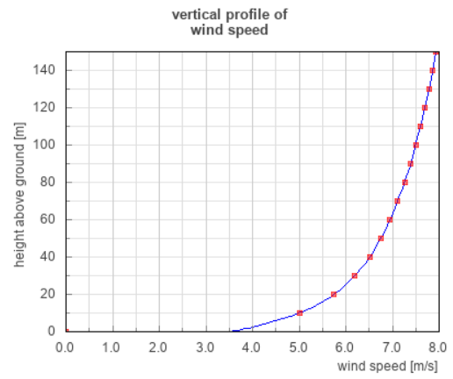To calculate the wind speed in different heights the following formula is being used:

Figure Vertical profile of wind speed

$$V_{2}=V_{1}{\left(\frac{h_{2}}{h_{1}}\right)}^{α}$$ We are then going to use this formula to calculate how much the speed of the wind will be at specific heights, to help us choose which model of wind turbine to use for our project. Results are attached below.

Where: $V_{1}$  
 is the windspeed measured at reference height 10 meters ( $h_{1})$ $V_{2}$
 is the windspeed at $h_{2}$ $a$ 
is the ground surface friction coefficient.

Table 2 Friction Coefficient table

|  |  |
| --- | --- |
| Terrain Characteristics | Friction Coefficient α (approx.) |
| Smooth hard ground, calm water | 0-0.10 |
| Tall grass on ground earth level | 0.15 |
| High crops, hedges and shrubs | 0.2 |
| Wooded countryside, many trees | 0.25 |
| Small town with trees and shrubs | 0.30 |
| Large city with tall buildings | 0.40 |

So, for both wind farms (onshore and offshore our coefficient will be around 0)  
Below are attached the results we got for different values of surface friction coefficient:

Table 3 Wind speed vs height vs Friction Coefficient

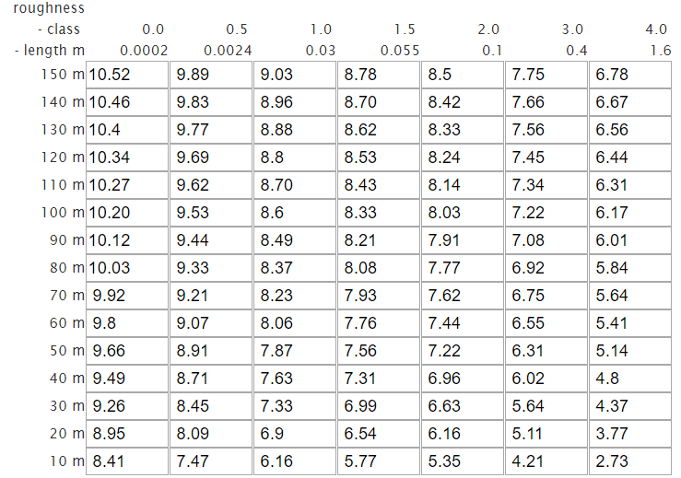

For the windfarm to be placed into the sea(offshore: α almost 0) then it is seen that the average wind speed will increase up to 10.52 m/s (for a chosen tower of 150m high), while if the windfarm is built at an area of ground surface friction of 0.2 it will drop down to 9.89m/s (for a chosen tower of 150m high).

The structure

As already mentioned, we are going to propose the design of two wind farms, one to be onshore and the other one offshore.   
We cannot use the same wind towers for both wind farms. That is because in the offshore windfarm because the maintenance is more difficult and expensive to do at the sea, the towers need to have much higher reliability and be resistant to corrosion and the more severe weather conditions that occur in the sea.   
They also need to be stronger (thicker and wider) to make the most of the strong wind current in the sea.   
This also is done by increasing the cut-out, which is the wind speed at which the wind turbine will shut down automatically to avoid any damage.

For our design on the land, the process of installing the towers on the ground is quite simple, quick and not as expensive as the offshore wind farm.

Type of offshore towers: Monopile

For the offshore wind farm we are going to use monopile which is the most common type of offshore wind farm foundations, for water up to 30m deep, because it is simple, cost efficient and has the least environmental impact compared to other support structures.  
The tower is made up of steel pipe and will have a very large diameter (6m) and a thick wall of 150mm. (see “b” in the figure below)

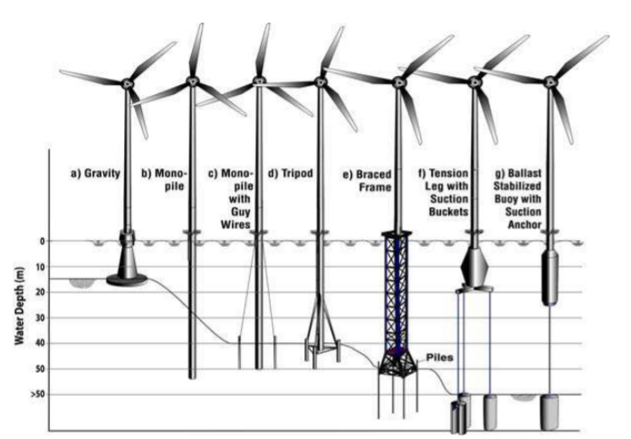

Figure 8 Various types of support structures and their applicable water depth (Malhotra, 2007b, c)

Type of onshore type: Octagonal gravity base foundation

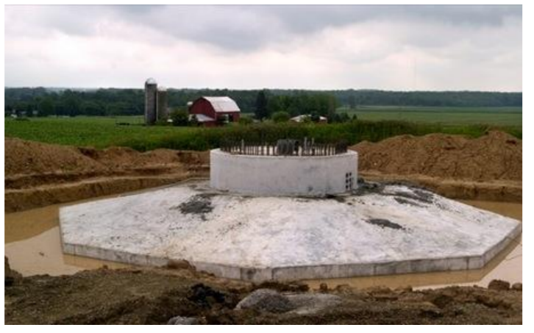For the installation of the onshore wind tower we are going to implement octagonal gravity base method which is one of the most common methods used for onshore wind farms. The diameter of the foundation will be 15m and the thickness 70cm on the edge and 3.0m at the center, with a total of 300 cubic meters of concrete and it will be buried to 2.5 meters beneath the ground.

Figure Octagonal Base Foundation

Driven Pipe Pile

The driven pipe pile option is a very commonly used way to install the tower in either deep waters or near shore wind farms, due to its efficiency.   
It basically floats the structure (i our case monopile) into the desired location and position, and then by using hydraulic hammers, the piles are driven inside the bottom of ocean. To do so, a floating crane vessel needs to be used.

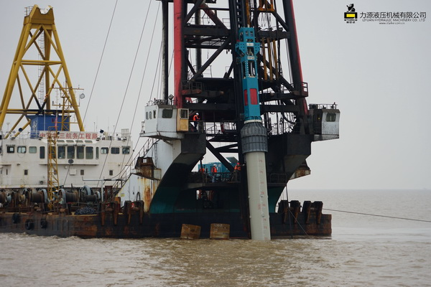The only disadvantage of using driven pipe pile would be the noise pollution in the sea waters generated by the hammers, which might disturb and impact the aquatic life for a short-time period, but it will definitely not create any long-term issues in the area. The strongest advantage though is the very short time needed to install a tower. It usually takes even less than 24 hours to install one unit.

Figure 10 HHP30 hydraulic hammer hammering φ1700mm, 82 meters long steel pipe pile

Wind turbines model selection

After doing all the research and analysis, we came to the conclusion to use these two different models. Our supplier was chosen to be Siemens, one of the leading manufacturers of wind farms in the world.

|  |  |
| --- | --- |
| **Off Shore wind tower** | |
| Model Number | SWT-7.0-154 |
| Type | 3-bladed, horizontal axis |
| Nominal Power | **7.0MW** |
| Blades | 75m fiberglass |
| Rotor Diameter | **154m** |
| Rotor tilt | 6 degrees |
| Swept Area | 18,600m2 |
|  |  |
| Position | upwind |
| Power Density | 253.2 W/m2 |
| **Generator** | |
| Type | Synchronous, PMG**, direct drive** |
| Voltage | 690 V AC |
| Frequency | 50 Hz/60Hz |
| Protection class | IP 54 |
| Power factor | 0.925 CAP – 0.925 IND |
| Yaw System | |
| Type | Active |
| Yaw bearing | Externally geared |
| Yaw drive | Electric gear motors |
| Yaw brake | Passive friction brake |
| Operational data | |
| Cut-in wind speed | 3 - 5 m/s |
| Nominal power at | 13 - 15 m/s |
| Cut-out wind speed | 25 m/s |
| Maximum 3 s gust | 70 m/s (IEC version) |

|  |  |  |
| --- | --- | --- |
| **On Shore wind tower** | | |
| Model Number | SG 3.4-132 | |
| Nominal Power | **3.465MW** | |
| Hub Height | 101.5 | |
| Rotor Diameter | **132m** | |
| Blades | 64.5m fiberglass | |
| Swept Area | 13,685m2 | |
| Power Density | 253.2 W/m2 | |
| **Generator** | | |
| Type | **Doubly-fed induction machine** | |
| Voltage | 690 V AC | |
| Frequency | 50 Hz/60Hz | |
| Protection class | IP 54 | |
| Power factor | 0.925 CAP – 0.925 IND | |
| **Yaw System** | | |
| Type | | Active |
| Yaw bearing | | Externally geared |
| Yaw drive | | Electric gear motors |
| Yaw brake | | Passive friction brake |

Table 4 Off Shore Wind Turbine Selection Table 5 On Shore wind turbine model

Energy Output

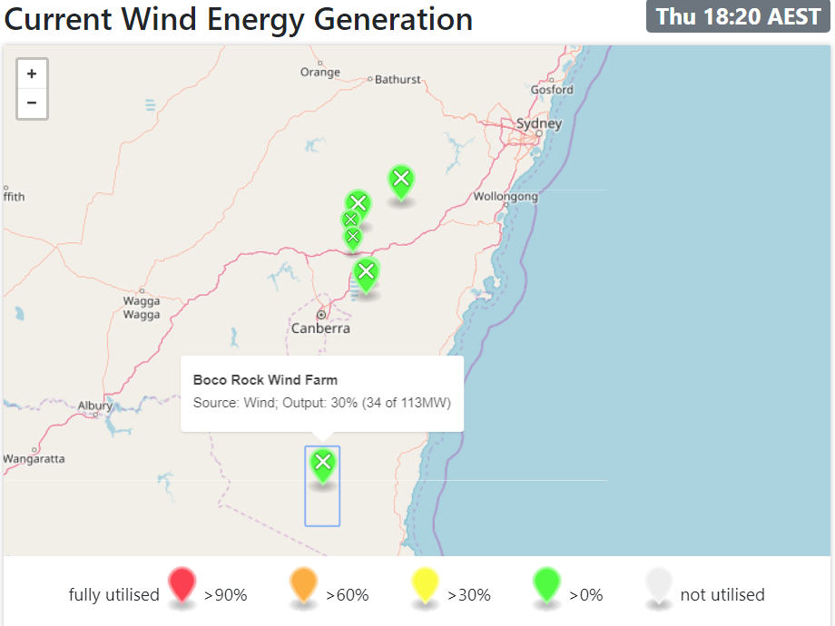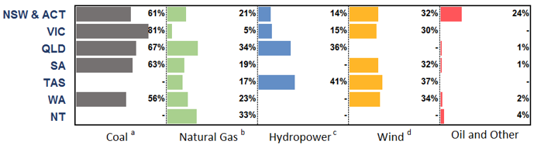Wind turbines are designed to generate enormous amount of energy. Sometimes they can blow constantly at high speeds for hours generating energy. Other times they might get stuck on low speeds for hours or days. Wind turbines unfortunately only operate at a fraction of their capacity throughout the year. That is what has been named as the **Capacity factor** of a power plant and below is some information gathered for the year 2015-2016 for each state and their main source of energy (Electricity Gas Australia, 2017)

Figure Capacity factor of power plants Australia

We can see that in NSW the capacity factor sits around 32%.

Below I am also attaching a live example taken on Thursday 11 October 2018 @18:20 AEST(19:20 in NSW, AEDT), and the stats are here verified, where we can see that the current wind generation at that time was at 30% of the maximum possible. (meaning that the capacity factor is 30%)

Figure Actual example of Capacity factor NSW

The above average of 32 capacity factor is expected to be slightly higher **(near 39%)** at an offshore wind farm.We are going to design our windfarms to have a total of 35 wind turbines.   
15 turbines for the Onshore windfarm and 20 Turbines for the Offshore windfarms.  
Calculations for the estimated annual energy output, considering the capacity factors for each wind farm, are presented below:

Table 6 Energy Output calculation

|  |  |
| --- | --- |
| **OnShore** | **Offshore** |
| Number of wind turbines: 15  Capacity each: 3.465MWh Total capacity Onshore: 52MWh | Number of wind turbines: 20  Capacity each: 7.0MWh  Total Capacity Offshore: 140MWh |
| Total Capacity combined: 192MWh | |
| **Estimated Energy generated / per year** | |
| OnShore_Expected =  Capacity*CapacityFactor*24(hours)*365(days) =52MWh*0.32*24*365=145,766MWh =**145.8GWh/year** | OffSShore_Expected =  Capacity*CapacityFactor*24(hours)*365(days) =140MWh*0.39*24*365=478,296MWh =**478.3GWh/year** |
| Combined Energy Generated per year = 145.8 + 478.3 = **624.1GWh/year** | |

**Energy translated in household usage:**After doing some research, we found out that the average home in NSW consumes 15.7kWh per day(Ausgrid,2017).   
That translates to 5,730kWh/year for an average household in NSW. $$\frac{energy produced/year}{average house use/year}=\frac{624.1*{10}^{9}}{5.730*{10}^{6}}=108.918 homes$$

**So, if our design successfully produces around 624.1GWh/year, that will be enough to provide electricity to 108,917 households in NSW.**

Table 7 Average home energy consumption NSW (Ausgrid, 2017)

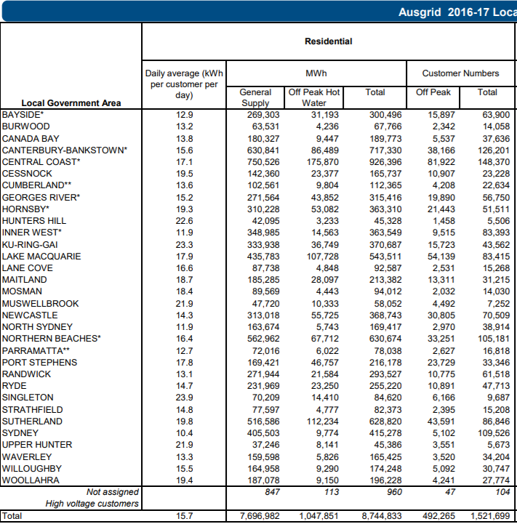

Transmission Network

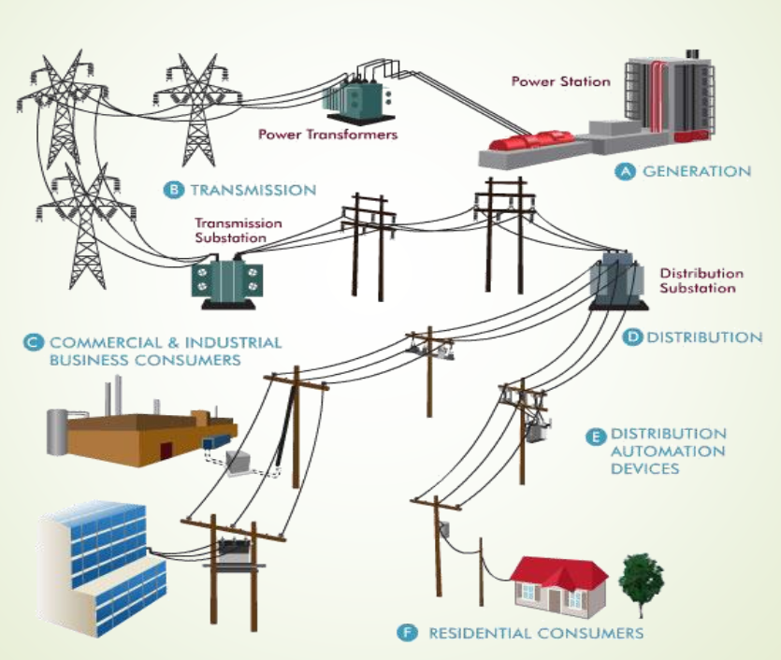

Figure 13 Transmission Network (Ha Pham 2018)

Once we have designed the power plants and the power is generated, we need to design an efficient network to distribute the electricity to the consumers, with the lowest energy loss possible.  
For this to be done there are some steps:

1. Step up power transformers: These transformers will step up the generated voltage from 25kV to 500kV to be suitable for long distance transmission lines.
2. Overhead transmission lines from the power station to the substation (including towers, conductors, insulators and quad bundle conductors).
3. Step down transformers (transmission substation): These transformers will step down the voltage from 500kV to 330kV to be suitable for the existing distribution substation and transmission lines in the areas of Wollongong, Newcastle, Sydney, Orange and Canberra.

Substations

Substations are used to increase or decrease the voltage, for it to be transmitted. Common voltages are usually 11kV, 22kV, 33kV, 66kV, depending on the purpose of use. For example, if it is to be transmitted to a residential area it will be usually 11kV.

There are mainly 4 different types of substations:

* Step-up transmission substation
* Step-down transmission substation
* Distribution substation
* Underground distribution substation (not used in our design)

**Step-up transmission substation:**Power is delivered here from the power plant and large power transformers are used to increase the voltage, for it to be delivered to long distances.

**Step-down transmission substation:**They change transmission voltage to sub transmission voltage, which are then appropriate to be delivered to distribution substations. In some cases, between the process of transmission from the step-down substation to the distribution substation, power can be tapped to be used for an industrial facility or something similar.

**Distribution Substation:**

They are located near the end-users. Voltage is changed from transmission or sub transmission level to lower level, for them to be used by the end-users. Here in Australia, it is usually 11k/415V. It is translated as a 3-phase circuit with grounded neutral source.

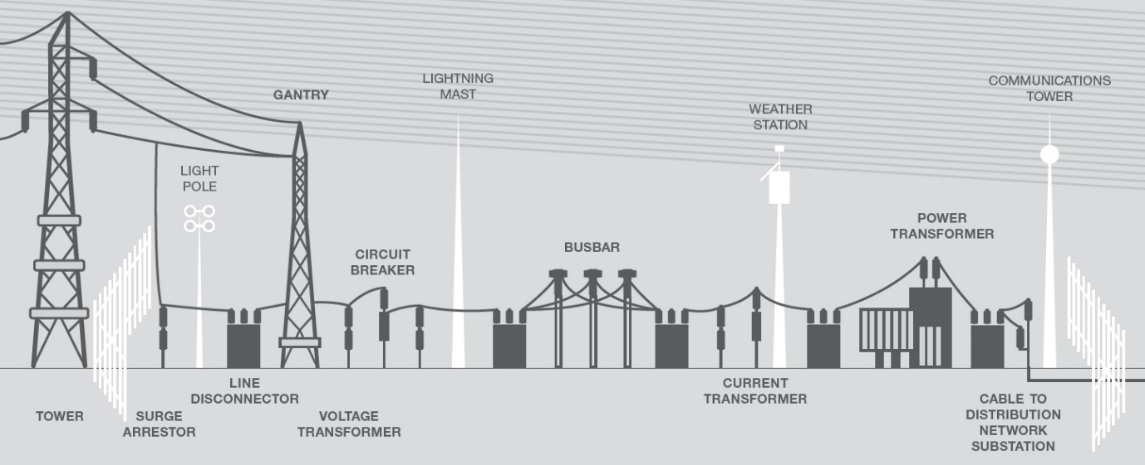

Figure 14 Distribution Substation diagram

Main components of a substation

Table 8 Main components of a Substation

|  |  |  |
| --- | --- | --- |
| Air circuit breakers | Used to interrupt the circuit when there is current flowing through them (when there is short circuit or overload) |  |
| Bus support insulators | Made from porcelain or fiberglass to prevent current leakage on the structure or the ground |  |
| Capacitor bank | Control the level of voltage by reducing or eliminating the voltage drop in the system caused by inductive reactive loads |  |
| Circuit switcher | Equipment protection for transformers, lines, cables and capacitor banks. Used to energize and deenergize capacitor banks |  |
| Control house | Where the switchboard panels, the meters, relays, supervisory control etc. are. |  |
| Potential Transformers | They provide accurate voltages for reading, for the customers to by billed |  |
| Transformers | Raising or lowering the voltage | Figure 3. Power Transformer, front view |
| Rectifiers | Connecting alternating current to direct | Figure 2. Rectifier |
| Distribution Bus | It routes power out of the station | Figure 2. Distribution bus |
| Grounding Resistors | Limiting ground fault current | Figure 1. Grounding resistor |
| Lightning Arresters | Preventing damage by limiting the surge voltage due to lighting strikes or faults. |  |
| Relays | Used to trigger the circuit breakers and other switches | Figure 1. Substation control panel relays |
| Suspension insulators | Separating the line conductors | Figure 1. Suspension insulators |
| Transmission bus | Leading power in the substation | Figure 1. Transmission bus |

* All pictures were taken from OSHA(OSHA, 2002)

Transformers

Each wind turbine will have a step-up transformer to boost the generated power of the generator. These are small transformers, located either on the basement(onshore) or on the hub of the wind turbine(offshore) and they are already included with the purchase of the wind turbine.

Then, all the wind turbines are interconnected to a collector step-up transformer at the sub-station (Transporco, 2016). We are not going to build a new substation, but we will investigate the most appropriate use of a transformer for the distribution system.

For the transformer on the distribution end of the system, we propose to be used a Delta to Wye transformer (Δ-Υ).   
It can also be seen in the diagram attached below, that by using a Delta-Wye transformer, the 3-wire system is transformed to a 4-wire system. That is desirable because the end user of this distribution line will mostly be unbalanced single phase residential houses.  
Having the 4th line on the receiving end, prevents overload in the phases, thus making the circuit balanced, by providing a path for the unbalanced line current to flow through (ground fault protection).  
Delta-Wye transformers are capable of handling unbalanced.  
In a Y-Y circuit, where there are 4 wires in each side, when there is unbalanced current in one side it can affect the other side, causing eventually damages in the circuit.

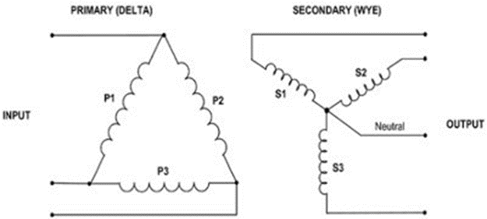

Figure 15 Delta-Wye circuit diagram

Transmission lines

Transmission lines are used to transmit the electricity that has been generated from the power plant to the substations and then to the consumers. In the process of designing them, the following considerations must be made:

* Distances between towers
* Configuration of towers
* Conductors arrangements
* Materials used
* Capacitance and inductance of the transmission lines
* What bundle type will be used

**Conductor arrangement on the tower**

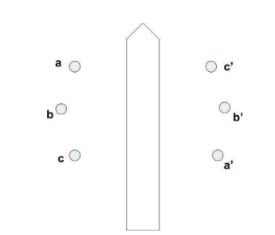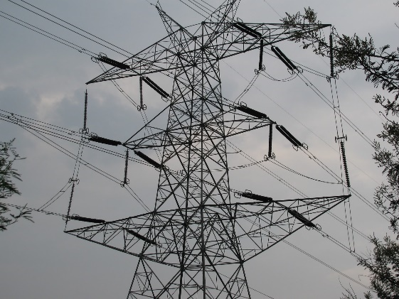Power lines and tower can have many different type of structures or material. They are usually made of steel or aluminum (lattice or tubular poles), concrete and sometimes from wood.   
The material and the structure of the tower depends on the voltage level, the weather conditions of the area (if its extreme conditions then stronger materials need to be used), the space availability, carrying weights and more.   
We are going to use Double Circuit overhead powerlines with each side supporting and insulating 6 conductors.

Figure Double circuit arrangement (PCT Spring 2018 Lecture slides)

Figure Double circuit Conductor arrangement

Conductors

Due to its attractive cost/efficiency ratio, we are using Aluminium Conductor Steel Reinforced(ACSR) conductors for our design, which are commonly used in high voltage transmission lines due to their durability and efficiency. 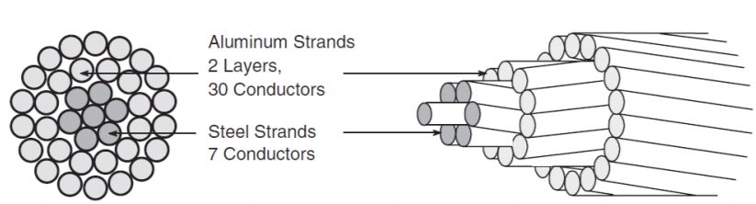

Figure 18 PCT Spring 2018 Lecture 3 slides

ACSR are cheaper and the weight less than copper conductors. “Aluminum possesses a conductivity-to-weight ratio twice that of copper and its strength-to-weight ratio is 30% greater than copper.” (F. Ridley Thrash, 2017). They also have a bigger diameter, which helps reduce corona effect, minimizing the power loss.

For our design of the transmission lines we are choosing to use the following conductor supplied from Prysmian with:

* cross sectional area of 2000mm or 2500mm
* Maximum DC-resistance at 20oC 0.0149 Ω/km and 0.0127 Ω/km respectively

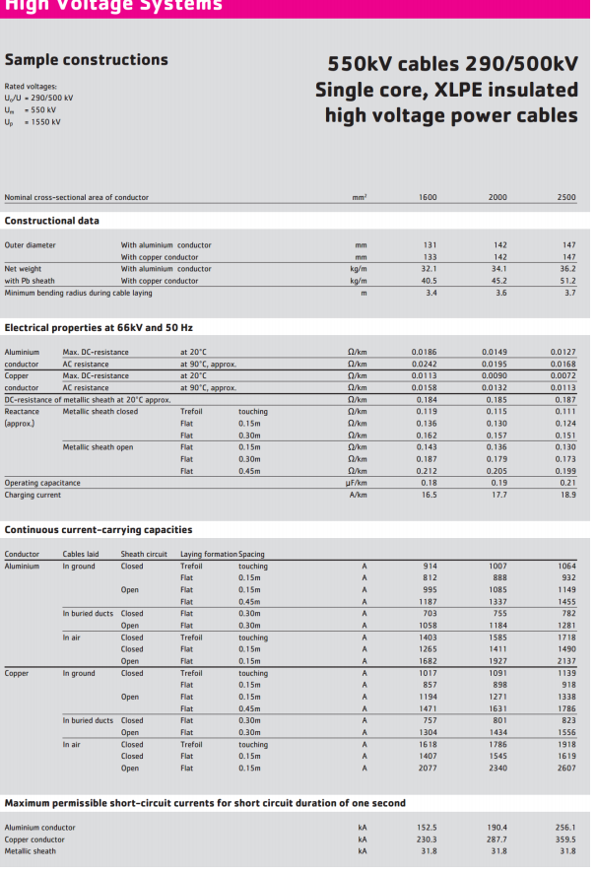

Figure Conductor Specifications

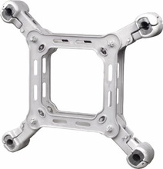In our design we are also including spacers, which are used to establish the distance between the conductors, to prevent any damage from potential high movement.

Figure Transmission lines Spacers

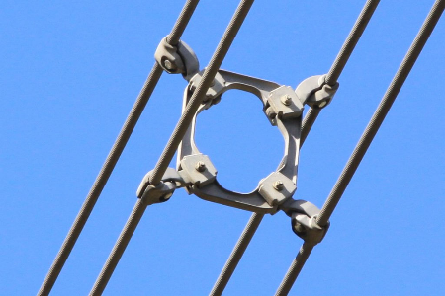

Capacitance and Inductance

When handling power and transmitting it in large distances, there is always power lose. All transmission lines exhibit the electrical properties of conductance, resistance, inductance and capacitance. The last two are an effect of Electromagnetic fields around the conductor.   
Inductance is based on the induced voltage in the circuit due to the of flux, a result of change in current, while conductance appears due to the potential difference between the transmission line conductors (Saadat, 1999).  
To design a transmission line model, these parameters are essential, and even though values are small, they add up in long distances.

To calculate the inductance and capacitance, we first have to calculate the Geometrical Mean Distance (GMD) and Radius (GMR) where by definition and from Lecture 3,4 notes, for a Quad bundle conductor double circuit, we have:

|  |  |
| --- | --- |
| $$GMR=\sqrt[n^{2}]{\left(D_{11}D_{12}D_{13}…D_{1n}\right)…\left(D_{n1^{'}}D_{n2^{'}}…D_{nm}\right)}$$ $$D_{s-bundle}=1.09\sqrt[4]{D_{s}d^{3}}$$ $$D_{s}=r^{'}=re^{-\frac{1}{4}}$$ $$\underset{⇒}{r=0.028, d=0.3} D_{s-bundle}=1.09\sqrt[4]{{0.028*0.3}^{3}}=0.181m$$ | $$GMD=\sqrt[mn]{{(D}_{{11}^{'}},D_{{12}^{'}}…D_{1m})…(D_{n1^{'}}D_{n2^{'}}…D_{nm}) }$$ $$⇒GMD= \sqrt[3]{D_{AB}D_{BC}D_{AC}}$$ Where: $$D_{AB}=\sqrt[4]{D_{ab}D_{ab'}D_{a'b}D_{a^{'}b^{'}} }$$ $$D_{BC}=\sqrt[4]{D_{bc}D_{bc^{'}}D_{b^{'}c}D_{b^{'}c^{'}} }$$ $$D_{AC}=\sqrt[4]{D_{ac}D_{ac^{'}}D_{a^{'}c}D_{a^{'}c^{'}} }$$ |
| $$L_{p}=2×{10}^{-7}\ln\left(\frac{GMD}{GMR}\right)$$ $$C_{n}=\frac{2πϵ_{0}}{\ln\left(\frac{GMD}{r}\right) }$$ For a quad bundle conductor, the resistance is simple calculated by adding each resistance in parallel (PCT spring 2018 lecture 3 slides): $$R_{eq}=\frac{1}{\frac{1}{R}+\frac{1}{R}+\frac{1}{R}+\frac{1}{R}}\underset{⇒}{R=0.0149} R_{eq}=3.725*{10}^{-3}Ω/km$$ | |

Transmission towers

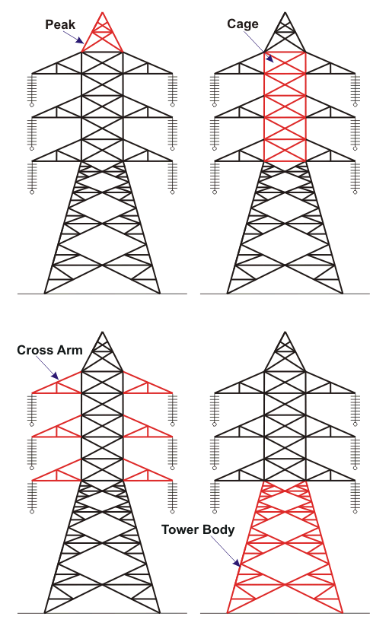Transmission tower are large steel structures used to carry high voltage powerlines.   
They required to be strong and high when in long distances (>250km) but also for medium transmission lines 80-250 km, because they need to withstand the heavy weight, the conductors and the insulators high above the ground (30-60m). The also serve the purpose of keeping the lines as far away as possible from contact with surrounding, to eliminate any risks or incidents.   
The higher you go above ground level, the stronger the wind speed is and that is why towers need to be carefully engineered to sustain any severe weather conditions.

Figure Main components of transmission towers

Lighting strike protection:  
We are including in our design a protection against lightings striking direct to the phase conductors. That is done by adding an earth wire (shield wire) on top of the structure (on the peak of the tower as seen in the figure). The conductors are kept within 30o  angle below earth wire. In case of a lightning strike, the lighting is more likely to hit the earth and discharge there without causing any damages.

We are using the same transmission tower as the existing ones on the current grid of NSW provided by Transgrid, with a separation distance of 450m between the peak each tower.

Distribution towers

In our design we are using the existing distribution system.  
The distribution system in NSW is mainly divided into 3 categories:

* The primary consumers, that need the electricity for commercial use and the voltage varies from 4-35 kV
* The secondary consumers that is a typical Australian home with 415V supply
* And as already mentioned in the section of substations, the sub transmission system, that is used to supply sub-stations, usually of 33kV, 66kV or 132kV

All these distribution lines are usually made of wood or concrete.

Most commonly used distribution lines are found below (SA GOV, 2017):

Table 9 Different types of distribution lines

|  |  |
| --- | --- |
| **415V distribution lines** | |
| Number of conductors: 4 Type and number of insulators: small pin insulators  Height: usually 6-7m | https://www.sa.gov.au/topics/energy-and-environment/using-electricity-and-gas-safely/powerline-safety/identifying-powerlines/?a=6202https://www.sa.gov.au/topics/energy-and-environment/using-electricity-and-gas-safely/powerline-safety/identifying-powerlines/?a=5787  Figure 23 415V power line   with 4 conductors  Figure 415V insulator |
| **11kV lines** | |
| They are usually mounted above 415V lines (as seen in the picture) Number of conductors: 3 bare  Type and number of insulators: single disc insulator or pin insulator made of 3 discs  Height: usually 8-9m | 11 kilo volt pin insulator  Figure 11kV insulator  Figure 25 11kV power like mouned  on top of 415V |
| **33kV lines** | |
| Number of conductors: 3 bare wires Type and number of insulators: 3-disc insulators or pin insulators made of 3 discs Height: 10-20m | Figure Glass disc insulator on 33kV powerline  Figure 27 33kV powerline with |
| **66kV lines** | |
| Number of conductors: 3 bare active wires Type and number of insulators: 5or 6 discs insulators or a post insulator made of 12 small discs Height: 10-20m | *Figure 30 66kV triangular powerline*  Figure 28 stack of discs  Figure Disc insulators |

PART 2  
**Analyse all types of possible bolted faults (symmetrical and unsymmetrical) which may occur at Sydney bus. Discuss how to protect against those faults.**

Unsymmetrical faults are the ones that lead to unequal currents and phase shifts in a 3-phase circuit and they occur when there is an open or short circuit of a line in the system.   
Some unsymmetrical faults that can possibly occur at the Sydney bus are listed below. When Zf=0 then we have a direct short circuit, which is called bolted fault (Grainger, 1994).

**Types of possible bolted faults**

Single line-to-ground fault:

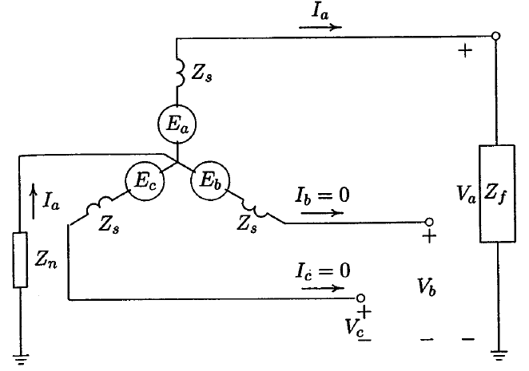This is the most common type of fault. It usually happens due to a lighting or when conductor drops or makes conduct with grounded structures (Grainger, 1994).   
The fault current can be found as:

$$I_{f}=I_{a}=3I_{a}^{0}=\frac{3E_{a}}{Z^{0}+Z^{1}+Z^{2}+3Z_{f}}$$

*\*methodogy and calculations can be found in Grainger textbook*

Figure 31 Single line-to-ground fault (Saadat 1999)

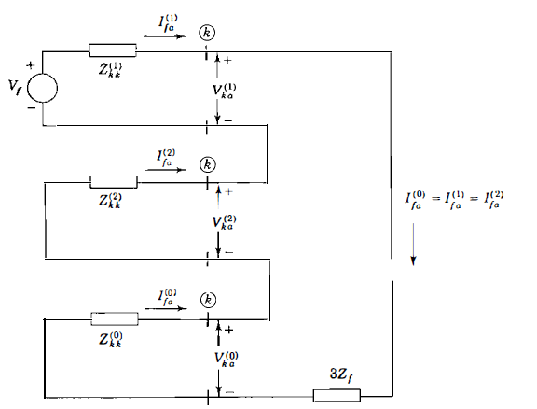Below is the connection of the Thevenin equivalents of the sequence networks to simulate a single line-to-ground fault on phase α at bus *k* of the system. Once the currents are known, the components of voltages at all other buses of the system can be determined from the bus impedance matrices of the sequence networks.

Figure 32 Sequence network for Single line-to-ground fault (Grainger, 1994)

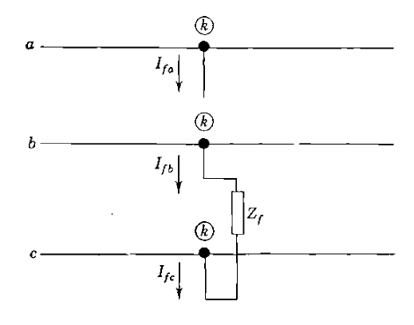Line-to-Line faults:

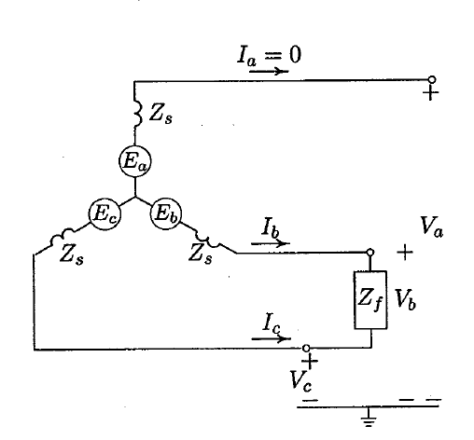Double Line-to-Line fault is when two lines are short circuited. This type of fault happens 5-15% of the time.  
  
In this example, bus *k* is the fault point and the line-to-line fault is on phased b and c. Assuming that the generator is initially at no load:   
Ifb = - Ifc  
Vkb - Vkc = IfbZf

Zf = 0

Figure Line-to-Line fault (Grainger, 1994)

Figure Line-to-line fault (Saadat, 1999)

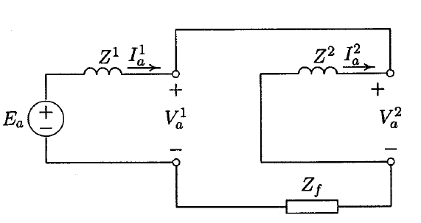  
  
The fault current is found to be $$I_{b}=\left(a^{2}-a\right)I_{a}^{1} \\ ⇒I_{b}= -j\sqrt{3}I_{a}^{1}$$  
*\*methodogy and calculations can be found in Grainger textbook*

Substituting for symmetrical components of currents, the symmetrical components of voltages and phase voltages at the fault point are obtained.

Figure Sequence network connection for line-to-line (Saadat, 1999)

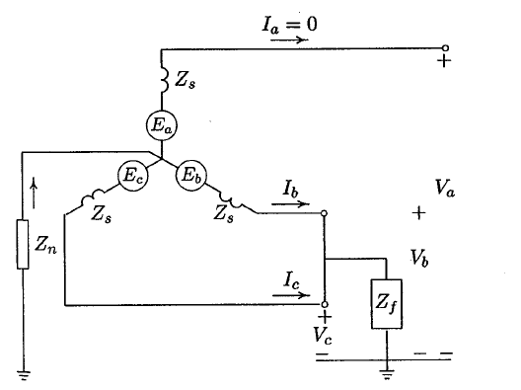Double Line-to-Ground faults:

This fault occurs when two lines are short circuited, and they come in contact with the ground.   
This type of fault occurs around 20-25% of the time.

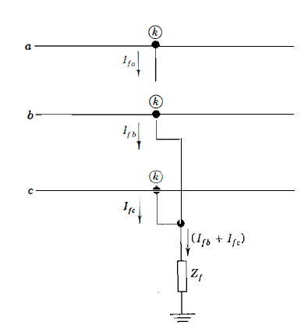  
  
  
  
  
  
  
  
  
Figure 36 Double Line-to-Ground fault (Saadat, 1999)

Figure Double line-to-ground fault (Grainger, 1994)

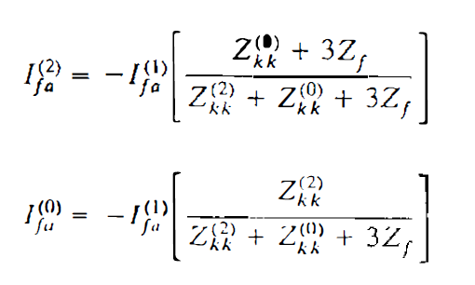The characterizing equations of the double line-to-ground fault are satisfied when all three of the sequence networks are connected in parallel:  
*\*methodology and calculations can be found in Grainger textbook*

$$⇒I_{f}=3I_{a}^{0}$$

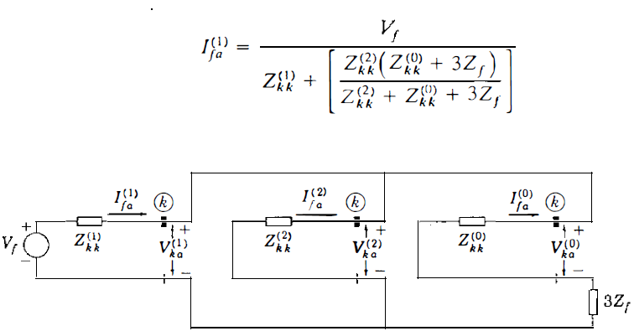



Figure Sequence network for Double line-to-ground fault

Protection Suggestion

**Switch to underground distribution system**A lot of faults often happen on buses, due to severe weather conditions, such as strong winds, fires, storms but also vegetation and debris falling or blowing into lines etc.   
Furthermore, medium and short transmission and distribution lines are in areas where there is high traffic activity. Many times, we have seen car accidents or trucks to come in contact or hit transmission towers or lines and cause different types of faults.   
All of these faults can easily be eliminated by switching to underground transmission and distribution line system (just like it has already been done in Sydney CBD, same can also be done for other areas nears Sydney Bus)

**Use SF6(Sulfur Hexafluoride) switchgear circuit breaker**

Another way to avoid such fault is to use SF6 circuit breakers, which are of live tank design. Thanks to auto puffer breaking technique, they do not generate operating voltages. SF6 is an electronegative gas which has a strong tendency of absorbing the free electrons(current).   
The contacts of the breaker remain open in a high-pressure flow SF6 gas and an arc is struck between them. The gas captures the conducting free electrons in the arc and forms relatively immobile negative ions. This loss of conducting electrons in the arc quickly builds up enough insulation strength to extinguish the arc (StudyElectrical, 2014).  
These circuit breakers are available for all voltages ranging from 144kV to 765kV and currents up to 8kA.  
This type of circuit breaker can be supplied by ABB, a global leader in power.   
Some of the advantages of SF6 are listed below:

* 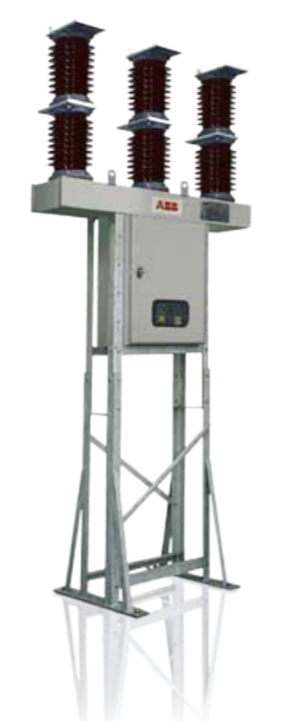The gas is non-inflammable, chemically stable, non-dangerous and approved to be used in NSW

Figure SF6 circuit breaker

* Elimination of electrical faults
* Excellent insulating properties
* It is not affected by weather conditions
* It produced no noise pollution
* Easy maintenance (once in 4-10 years)
* 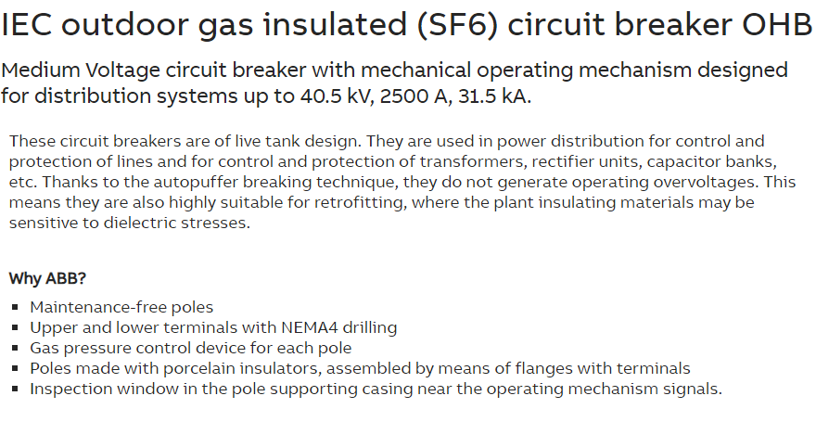Same gas is re-circulated in the circuit, minimizing the need of SF6

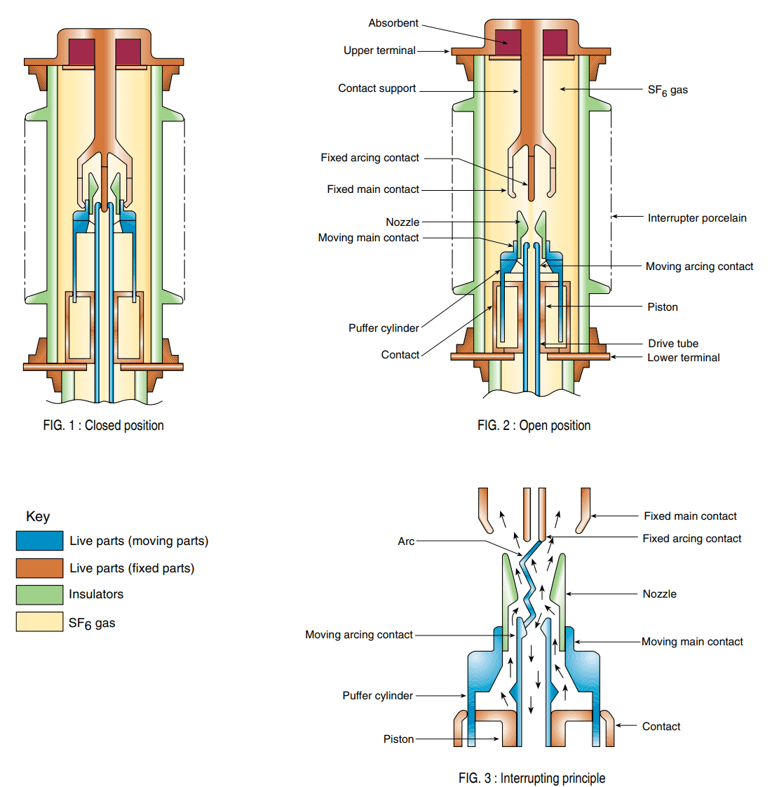In the figure in the below is an illustration of how the breaker will work:

Figure Breaking procedure

References

Georgios Statiris References

ABB 2018, IEC outdoor gas insulated (SF6) circuit breaker OHB, ABB, viewed 10th October 2018, <https://new.abb.com/medium-voltage/apparatus/circuit-breakers/outdoor/iec-outdoor-gas-insulated-(sf6)-circuit-breaker-ohb>

ABB 2018, Large offshore wind turbine transformers for collection grid at 33 kV and 66 kV, WindSTAR transformers, viewed 10th October 2018,<<https://search-ext.abb.com/library/Download.aspx?DocumentID=9AKK107045A0972&LanguageCode=en&DocumentPartId=&Action=Launch>>

AEMO 2017, Interactive Map, INTERACTIVE MAPS AND DASHBOARDS, viewed 3rd October 2018, <<http://www.aemo.com.au/aemo/apps/visualisations/map.html>>

Aneroid Energy 2018, Current Wind Energy Generation, Wind power in the Australian Energy Market, viewed 11th October 2018, <<https://anero.id/energy/wind-energy>>

Ausgrid 2017, Ausgrid 2016-17 Local Council Community Electricity Report, Ausgrid, viewed 11th October 2018,<<https://www.ausgrid.com.au/-/media/Documents/Data-to-share/Average-electricity-use/Ausgrid-average-electricity-consumption-by-LGA-201617.pdf>>

AusNetServices 2018, Transmission – Easement, Aus Net Services, viewed 15th October 2018, <<https://www.ausnetservices.com.au/Business/Electricity/Safety/Transmission-Easements>>

Dylan Lu 2018, Renewable Energy Systems – Chapter 2. Wind Energy, School of Electrical Mechanical and Mechatronic Systems UTS, viewed 15th September 2018, < https://online.uts.edu.au/bbcswebdav/pid-2846827-dt-content-rid-33137888_1/courses/48550-2018-SPRING-CITY/API%20RES_Chapter_2_Wind%20Energy_2017.pdf>

DWIA 2018, Wind Turbine Power Calculator, viewed 13th October 2018, <<http://xn--drmstrre-64ad.dk/wp-content/wind/miller/windpower%20web/en/tour/wres/pow/index.htm>>

Engineering Feed 2017, Electrical Transmission Tower Types and Design, <<http://engineeringfeed.com/electrical-transmission-tower-types-design>>

Engineers Australia 2015, Power generation/distribution, Engineers Australia, viewed 10th October 2018, <<https://www.engineersaustralia.org.au/sites/default/files/resource-files/2017-01/Div_New_engStudies_personal_public_transport_part_1.pdf>>

Engineers Australia 2017, The Future of Australian Electricity Generation, Engineers Australia, <<https://www.engineersaustralia.org.au/sites/default/files/resources/Public%20Affairs/The%20Future%20of%20Australian%20Electricity.pdf>>

F. Ridley Thrash 2018, Transmission Conductors - A Review of the Design and Selection Criteria, Southwire, viewed 17th October 2018,<<https://www.southwire.com/support/TransmissionConductoraReviewOfTheDesignandSelectionCriteria.htm>>

Grainger, J. & Stevenson, W. 1994, *Power System Analysis,* 1st edn, McGraw-Hill, Inc., Singapore.

Ha Pham 2018, PCT 48572 Lecture 3 slides, viewed 23rd August 2018, < https://online.uts.edu.au/bbcswebdav/pid-2847557-dt-content-rid-33139594_1/courses/48572-2018-SPRING-CITY/Lecture3.pdf>

Osha 2018, Electric Power eTool: Substation Equipment – Relays, viewed 7th October 2018,<https://www.osha.gov/SLTC/etools/electric_power/illustrated_glossary/substation_equipment/relays.html>

SA GOV 2018, Identifying powerlines, Powerline safety, SA GOV, viewed 16th October 2018, <<https://www.sa.gov.au/topics/energy-and-environment/electrical-gas-and-plumbing-safety-and-technical-regulation/powerline-safety/identifying-powerlines>>

Study Electrical 2018, Sulphur Hexafluoride (SF6) Circuit Breakers, viewed 10th October 2018,< <http://www.studyelectrical.com/2014/07/sulphur-hexaflouride-sf6-circuit-breaker-construction-working-advantages.html>>

Tran C. 2017, Capacity factors: Understanding the misunderstood, Australia Energy Council <https://www.energycouncil.com.au/analysis/capacity-factors-understanding-the-misunderstood/>

Watch, N. 2018, National Wind Watch | Output from Industrial Wind Power, viewed 13th October 2018 <<https://www.wind-watch.org/faq-output.php>>

Phi Dinh References

<https://www.smh.com.au/business/companies/origin-aims-to-halve-emissions-by-2030s-20171214-p4yxpg.html>

<http://www.population.net.au/sydney-population/>

<http://www.population.net.au/population-of-new-south-wales/>

http://www.climatechangeauthority.gov.au/sites/prod.climatechangeauthority.gov.au/files/files/SR%20Electricity%20research%20report/Electricity%20research%20report%20-%20for%20publication.pdf

<https://www.aemo.com.au/Electricity/National-Electricity-Market-NEM/Data-dashboard>

<https://en.wikipedia.org/wiki/Submarine_power_cable>

<https://www.epa.nsw.gov.au/-/media/epa/corporate-site/resources/soe2015/150817-soe-3-energy-consumption.pdf>

<http://www.population.net.au/wollongong-population/>

<https://drive.google.com/open?id=1rzO1t90GiatE0L5eTAjeOo0cxjCHGdwW&usp=sharing>